Design Plan for Unbeatable Website
Ethan Fyhn
Sept. 30th, 2026

What is this for:
Unbeatable is a band formed to rebel against the “No music policy” brought upon by Harmony And Resonance Management (H.A.R.M.) as a way for people to still revel in the enjoyment of Indie music.

Website Pages:
Landing page – Customers will be placed here when interacting with any “Home” element where they can easily get to any service they would need.
Concert Info – The page where newest venues and ticket prices are sold and posted. With videos of previous concerts. (Gameplay provided by me)
Inquiry – For any user who wishes to request feedback and report issues. Will include the website developers (me and other classmates)
About us – The list of band members and a short biography about them.
Working Hours – Schedule information for users to see current working hours, and availability.

Who is this for:
This website would be for fans, preferably people aged between 20-30 as they would be able and understanding if they were to get caught by H.A.R.M. they would be responsible for the repercussions.

Colour Palette:
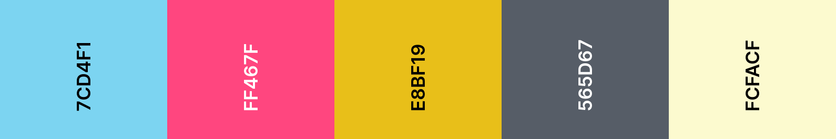
#7CD4F1 – Showing a link that can be interacted with through the underline colour.
#FF467F – Accent colour used for most border and adjacent elements.
#E8BF19 – Will display when hovering over interactable text, alternatively used as a minor accent colour.
#565D67 – Main text colour for clickable elements.
#FCFACF – Main background colour.
As of 09/30/26 colours are subject to change roles but colours will not change values.

Band logo:
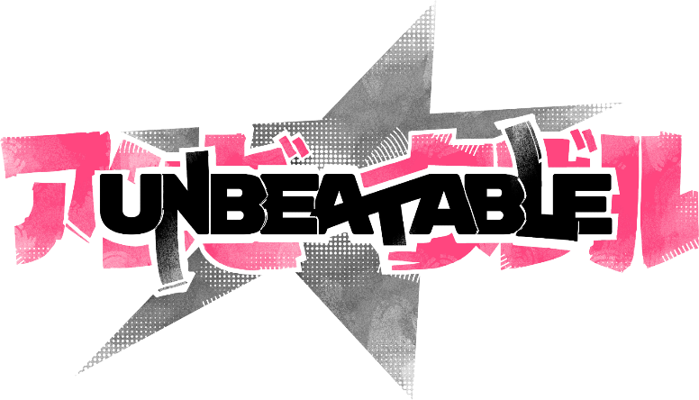
Band logo is sourced from the games official website

Design Plan
Mobile plan for landing page
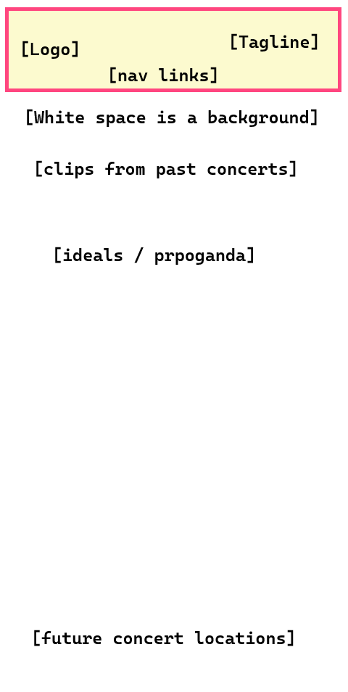

Desktop plan for landing page
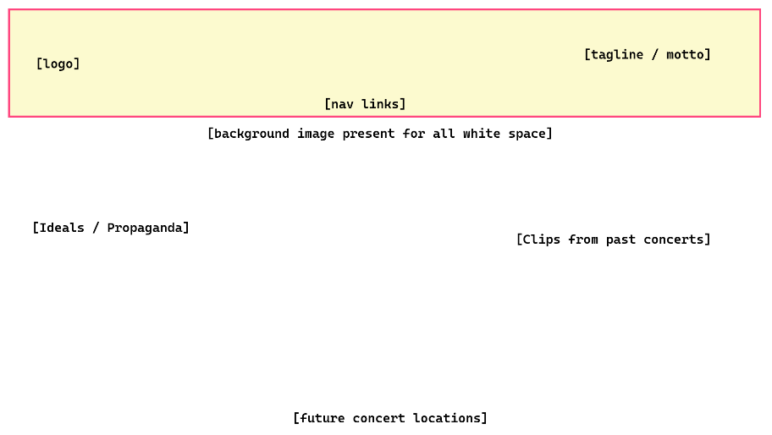

Website Banner:
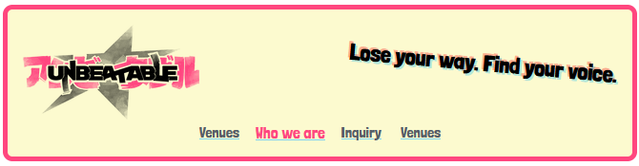
Some of the required elements and CSS properties to make this happen would include:
- Text decorations
- Padding
- Borders
- Background color
- Text Shadows
- Flex Containers
- Transformations
- Justify-content

